Output for Syntax for all loop Statements Tasks

For loop statement

For loops in to break and continue

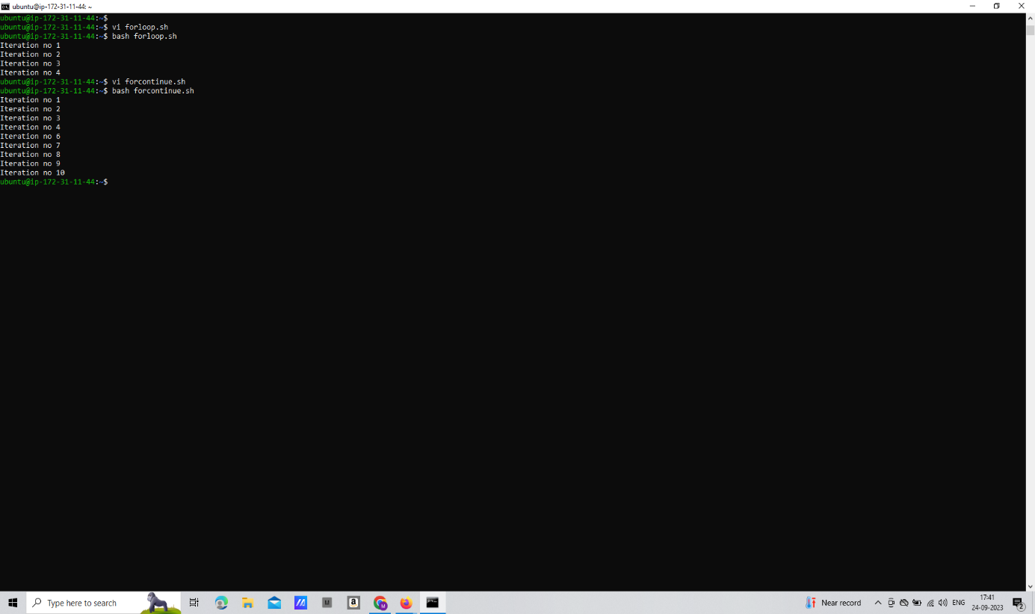

While Loop Statement

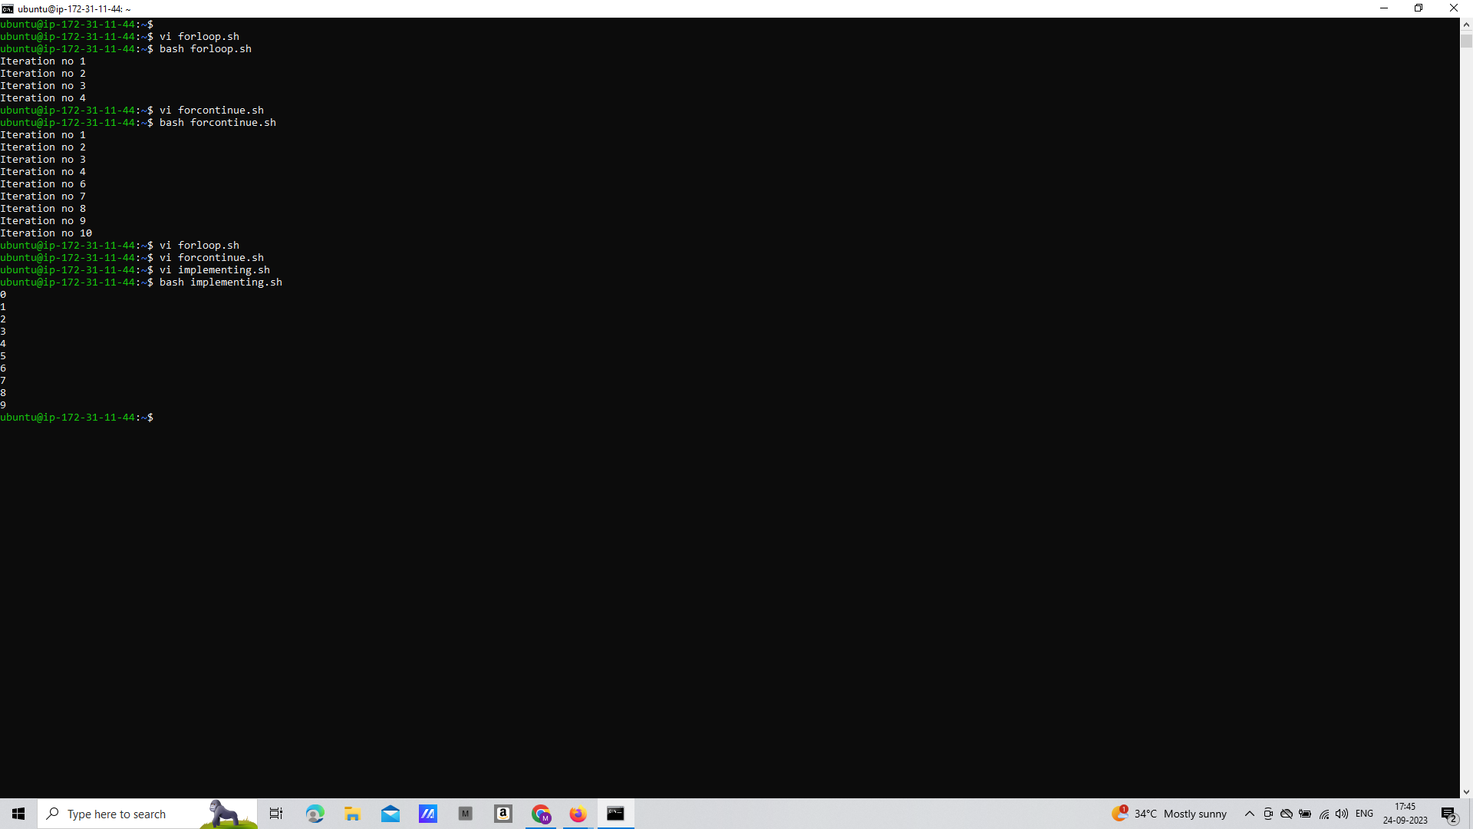

Until loop statement

